SET 12 – Website Traffic Analysis
Q1. Line Chart
traffic <- data.frame(
Date=as.Date(c("2023-01-01","2023-01-02","2023-01-03")),
PageViews=c(1500,1600,1400),
CTR=c(2.3,2.7,2.0)
)
plot(traffic$Date,
traffic$PageViews,
type="o",
pch=16,
col="blue",
xlab="Date",
ylab="Page Views",
main="Daily Page Views")
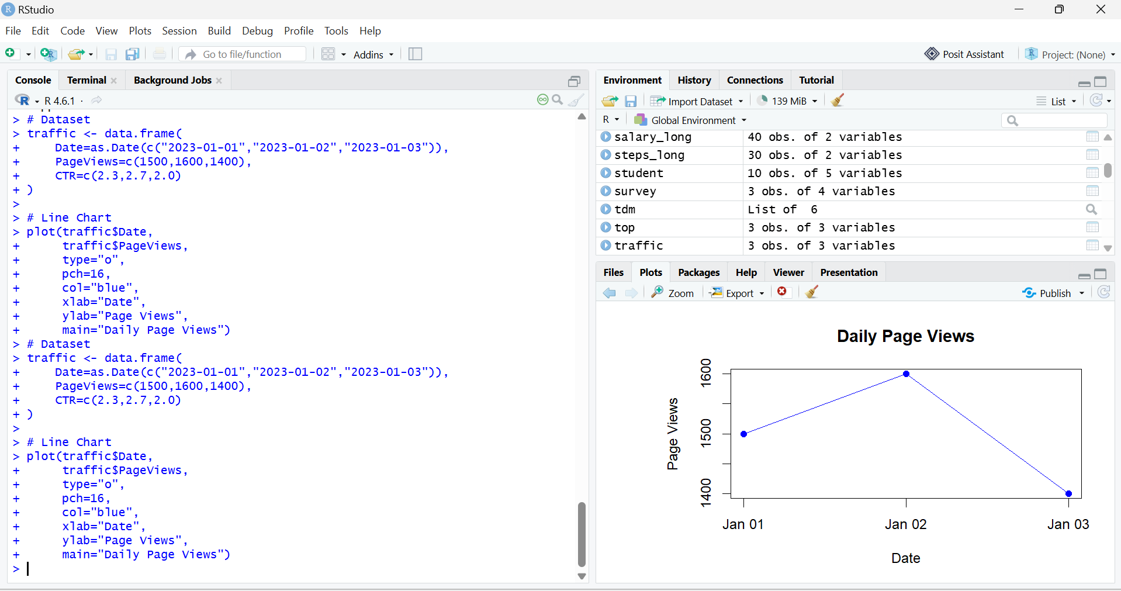

Q2. Bar Chart
traffic <- data.frame(
Date=c("2023-01-01","2023-01-02","2023-01-03"),
PageViews=c(1500,1600,1400),
CTR=c(2.3,2.7,2.0)
)
barplot(traffic$CTR,
names.arg=traffic$Date,
col="orange",
xlab="Date",
ylab="Click-through Rate (%)",
main="Click-through Rate by Day")
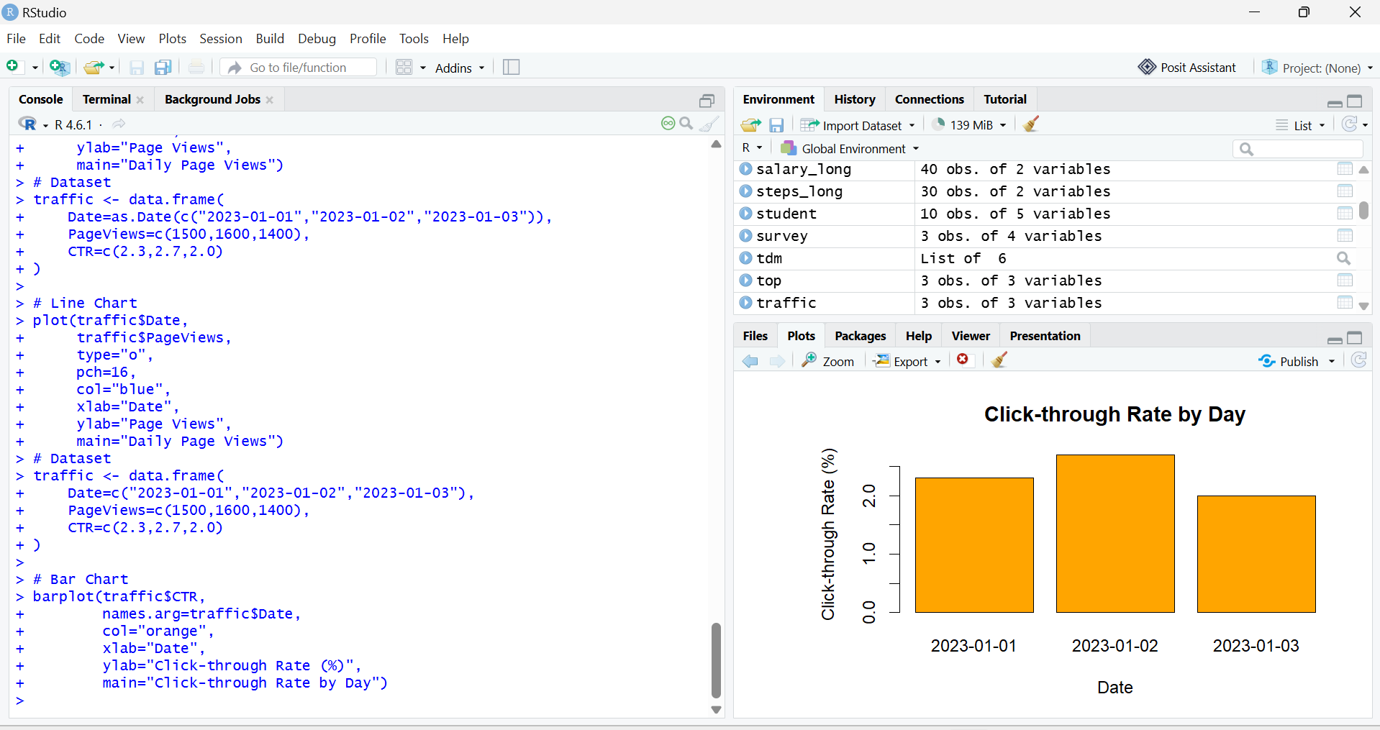

Q3. Table
traffic <- data.frame(
Date=c("2023-01-01","2023-01-02","2023-01-03"),
PageViews=c(1500,1600,1400),
CTR=c("2.3%","2.7%","2.0%")
)
Traffic
